Lets play out a story hand that does not start with consensus. The customer deals the story. Programmers ponder their estimate. All together, they flip over their card. The current story hand looks like this:

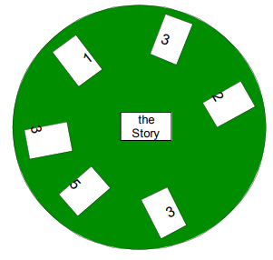

The programmers at the extremes start the discussion. It might go something like this.

“Why do you think this story is so hard?”

“Why do you think this story is so easy? Did you think about having to modify the

communications protocol? The last time we did that it cost us four days alone!”

“Yeah, but this is basically the same as the last time we changed the protocol and all

we have to do is add another message class”

“OK, but it is still not a one”

blah… blah… blah

“Let’s call it a three”

“OK, Done”

Do you remember the other problem mentioned in the opening paragraph? Not all meeting

attendees were participating. Now all participants are players in the game. They all have to

be a turtle and stick their neck out when they play their card. Everyone gets experience at

estimating. The whole team plays the game, not just the most vocal, or most senior.

Everyone participates.

This idea of getting consensus without discussion sounds weird but does work. It can be used in other areas besides planning. Those less likely to participate will have input into the plan. There are many good ideas in your more quiet people. Common ground and differences become evident. The team can focus its energy on the differences and not waste valuable time on where they already agree. I have seen this positively impacted the team’s story estimation velocity. Instead of spending 10, 20, or 30 minutes on each story, most stories estimates took a minute or so.

About the card deck Attached to this paper is a set of cards. Print them on perforated 3x5 note card stock. One set for each player. You may notice there are some gaps. The deck is designed for unitless numbers or ideal programming days. As the estimates get longer, the precision goes down. There are cards for 1,2,3,5,7,10 days and infinity. This deck might help you keep your story size under 2 weeks. Its common experience that story estimates longer than 2 weeks often go over budget. If a story is longer than 2 weeks, play the infinity card and make the customer split the story. If you really feel compelled to play a 4, 6, 8, or 9, go ahead an use two cards at once. I bet that the added precision probably won’t help a lot

[Microsoft Word - PlanningPoker-v1.1.doc (agileleanhouse.com)](https://www.agileleanhouse.com/lib/lib/Topics/Estimation/PlanningPoker-v1.1.pdf)

Grenning, J. (2002). Planning poker or how to avoid analysis paralysis while release planning. *Hawthorn Woods: Renaissance Software Consulting*, *3*, 22-23.

[Sobre el uso del póquer de planificación para estimar historias de usuario - ScienceDirect](https://www.sciencedirect.com/science/article/abs/pii/S0164121212001021)

Mahnič, V., & Hovelja, T. (2012). On using planning poker for estimating user stories. *Journal of Systems and Software*, *85*(9), 2086-2095.